**DESIGN OPTIMIZATION OF AIR FILTER TOP HOUSINGS FOR WEIGHT REDUCTION AND AESTHETIC IMPROVEMENT**

**Self-project**

**Aman Shrivastava**

**Manufacturing at IITG**

**ABSTRACT**

This study presents an analytical and simulation-based approach for optimizing the design of filter top housing using topology optimization techniques. The filter top housing is a crucial component of a filtration system, which protects the filter media and ensures proper airflow and pressure drop across the filter. The proposed approach involves conducting a detailed analysis of the existing filter top housing design and identifying the key areas for improvement such as reduction in weight.

The topology optimization technique is employed to optimize the shape, size, and weight of the filter top housing, while considering structural strength. The simulation study is carried out using Static structural analysis with the help of ANSYS to evaluate the performance of the optimized design.

The results of the study indicate that the optimized filter top housing design exhibits a significant improvement by reducing weight, while maintaining structural strength. Additionally, the redesign is applied to modify the existing filter top housing design and validate the effectiveness of the proposed approach

**Air filter:**

Air filters are used in industrial applications to remove contaminants from the air. These contaminants can include dust, dirt, pollen, smoke, and fumes. Air filters are essential for protecting equipment and personnel from these contaminants. There are many different types of air filters used in industrial applications. Some of the most common types of air filters include pleated filters, HEPA filters, activated carbon filters, and ULPA filters.



Filter top housing

**Material used:**

LM6 is a high-strength aluminum alloy that offers excellent properties and finds diverse applications in various industries. It is known for its exceptional mechanical properties, corrosion resistance, thermal conductivity, and dimensional stability. These characteristics make LM6 a suitable choice for filter top housing in air filtration systems.

One notable property of LM6 is its high strength and stiffness. This makes it well- suited for applications where structural integrity is crucial. In the context of filter top housing, the strength of LM6 ensures that the housing can withstand mechanical stresses and vibrations, providing robust and durable support for the filtration components.

LM6 is also known for its machinability, which refers to its ease of shaping, drilling, and forming. This property enables the production of intricate designs and customized solutions for filter top housing. It allows manufacturers to create complex geometries and tailor the housing to specific filtration system requirements.

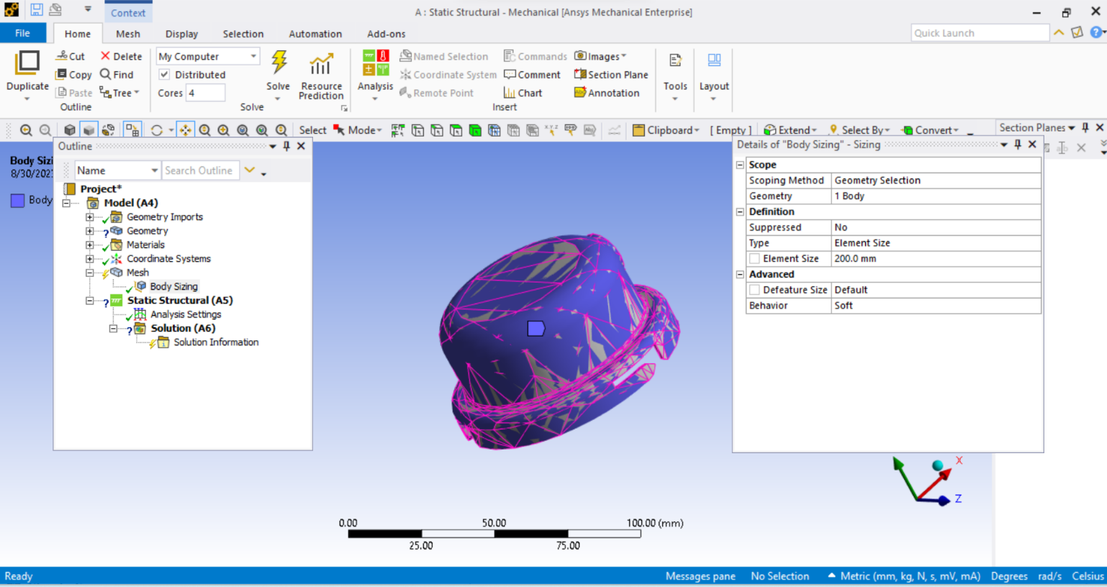

Using **ANSYS**

**Material selection**: LM6

Material properties of LM-6

|  |  |
| --- | --- |
| **Property** | **LM-6** |
| Tensile strength | 160-190 MPa |
| Yield strength | 140-170 MPa |
| Elongation | 5% |
| Hardness | 50-55 HB |
| Melting point | 630-645°C |
| Specific heat capacity | 900 J/kgK |
| Thermal conductivity | 160 W/mK |
| Electrical conductivity | 33.5 MS/m |
| Corrosion resistance | Good |
| Machinability | Fair |

Compression of LM-6 & ADC12

|  |  |  |
| --- | --- | --- |
| **Property** | **LM-6** | **ADC12** |
| Tensile strength (MPa) | 160-190 | 200-220 |
| Yield strength (MPa) | 140-170 | 170-190 |
| Elongation (%) | 5 | 4 |
| Corrosion resistance | Good | Good |
| Machinability | Fair | Good |

|  |  |  |  |  |  |  |  |
| --- | --- | --- | --- | --- | --- | --- | --- |
| Element | Iron | Silicon | Magnesium | Manganese | Copper | Zinc | Aluminum |
| Percentage | 0.20% | 11.50% | 0.06% | 0.30% | 0.09% | 0.07% | Remainder |

**Methods and formula used :**

**ANALYTICAL STUDY**

The filter top housing can be considered as a thick cylinder under internal pressure. we can have a study on the stress acting on the filter housing due to internal pressure by comparing it with a thick hollow cylinder. The ID and OD of the filter housing is measure using digital vernier caliper and the stress on it are analytically calculated. Below are the analytical equations used for the various stress calculation.

The stress in the axial direction at a point in the cylinder wall can be calculated using the following formula represented as Eq.

where,

pi = internal pressure in the cylinder (MPa)

σa = stress in the axial direction (MPa)

po = external pressure in the cylinder (MPa)

ro = external radius of cylinder (mm)

ri = internal radius of cylinder (mm)

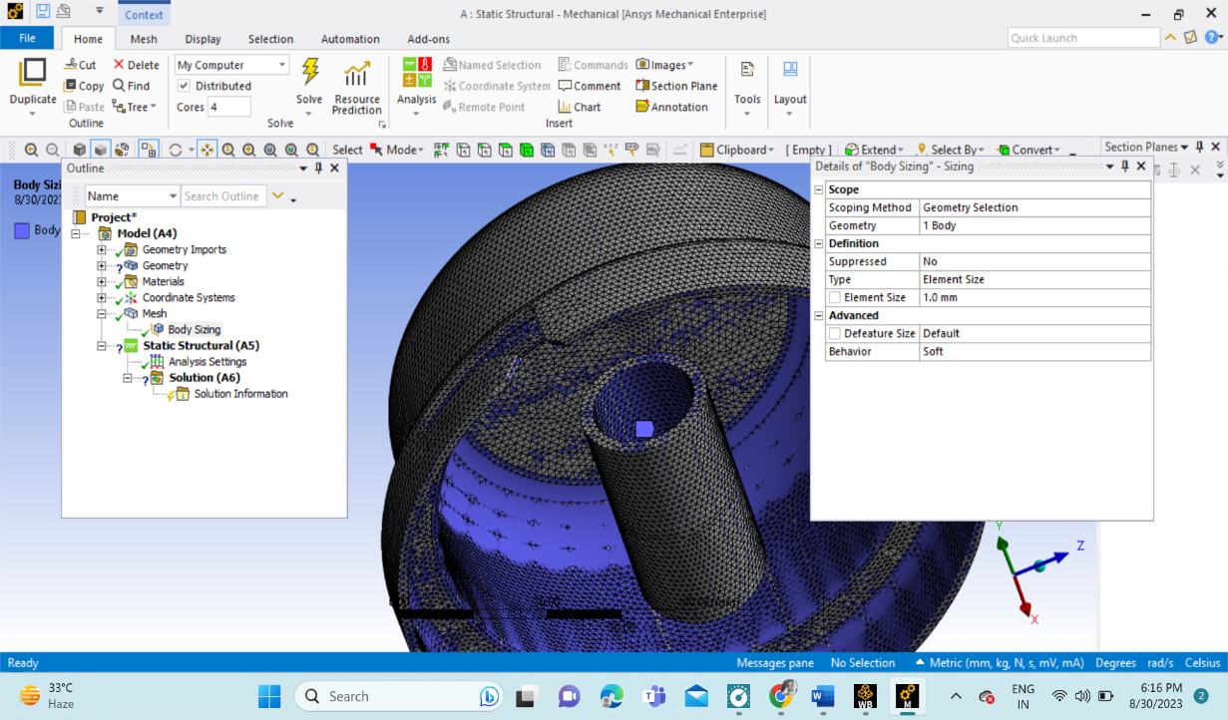**\**

**Pressure applied inside the walls is 2.6Mpa**

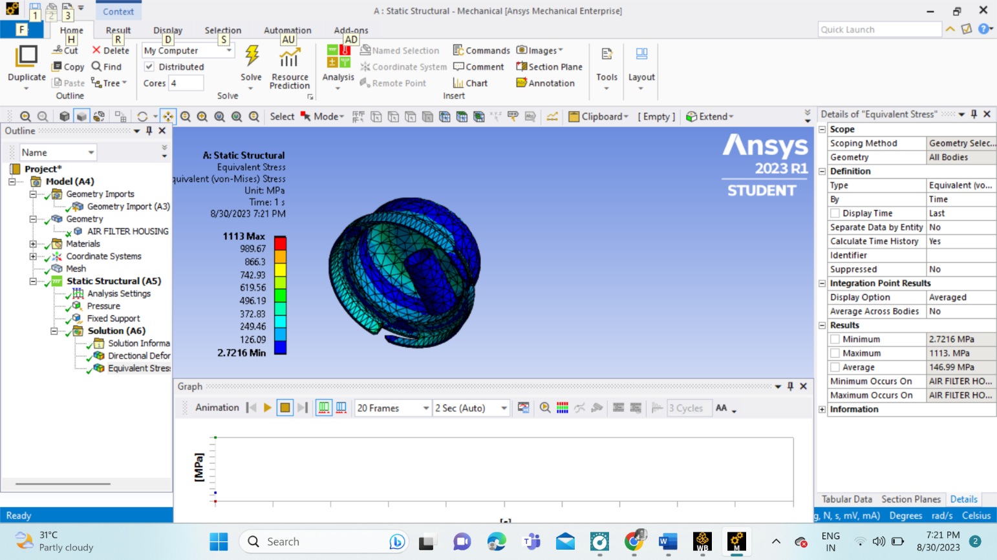

Equivalent stress (Von-Mises stress) results

**Result and conclusion:**

|  |  |  |  |
| --- | --- | --- | --- |
| Table 4.3: Comparison of analytical and simulation results of model **Type of Stress** | **Analytical Results (MPa)** | **Numerical Results (MPa)** | **% Deviation** |
| Axial Stress | 14.3 | 13.25 | 7.35% |
| Hoop Stress | 28.5 | 23.655 | 17% |
| Radial Stress | 0 | 0.0615 | NA |

In this paper, a study on design optimization study of air filter top housings for weight reduction and aesthetic improvement was presented. The study was conducted using a combination of analytical, simulation, and optimization techniques.

● The analytical methods used were based on the principles of stress analysis and structural mechanics to reduce the wall thickness of the filter top housing from 10mm to 5.75mm.

● Sample CAD model has been designed based on the analytical results. And the CAD model was used for static structural simulation.

● Furthermore, Topology optimization study was also done based on the static structural results obtained.

● Multiple models were designed based on the topology optimization results to obtain a final model.

● The final models show a final weight of the part to be 1037.04 grams, which is 35.98% reduction from the original weight (1620 grams)

The results of this study demonstrate the potential of analytical methods and topology optimization technique to be used to reduce the weight of structural components while still maintaining their structural integrity and aesthetics of the part. This approach could be used to improve the performance and efficiency of a wide range of products.